**LAPORAN PRAKTIKUM**

**PEMROGRAMAN BERORIENTASI OBJEK 9**



Nama : Ghifar Januar Abdillah

NPM : 4523210051

**Dosen : Adi Wahyu Pribadi**

**S1-Teknik Informatika**

**Fakultas Teknik Universitar Pancasila**

**2024**

1. app

* Library.java
* Main.java

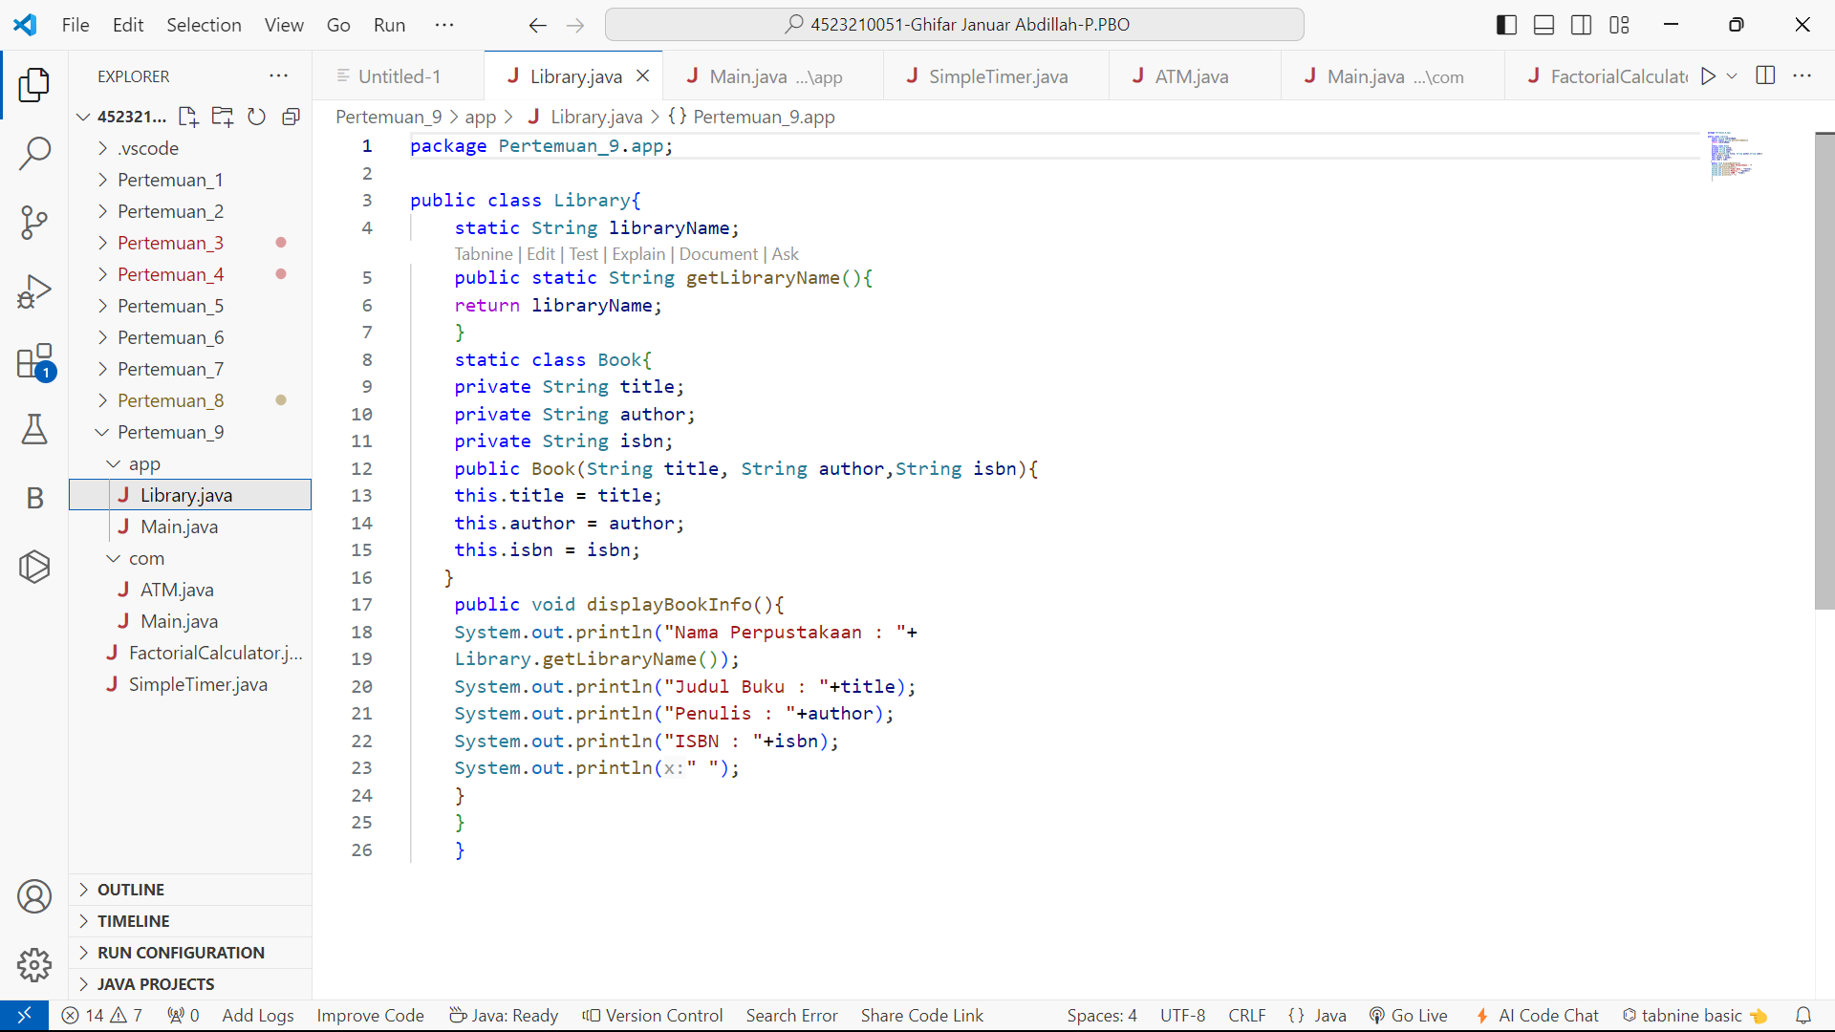

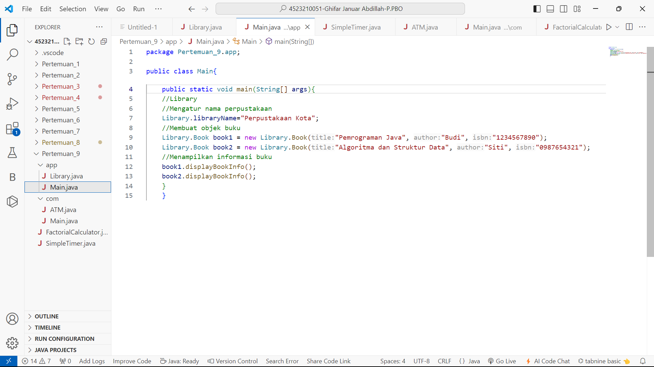

* Hasil Running

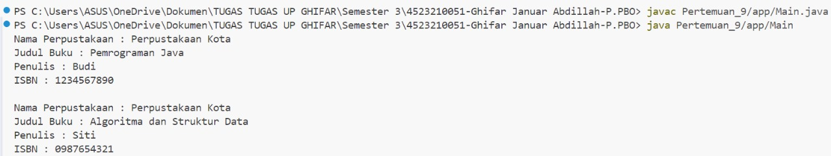

1. com

* ATM.java
* Main.java

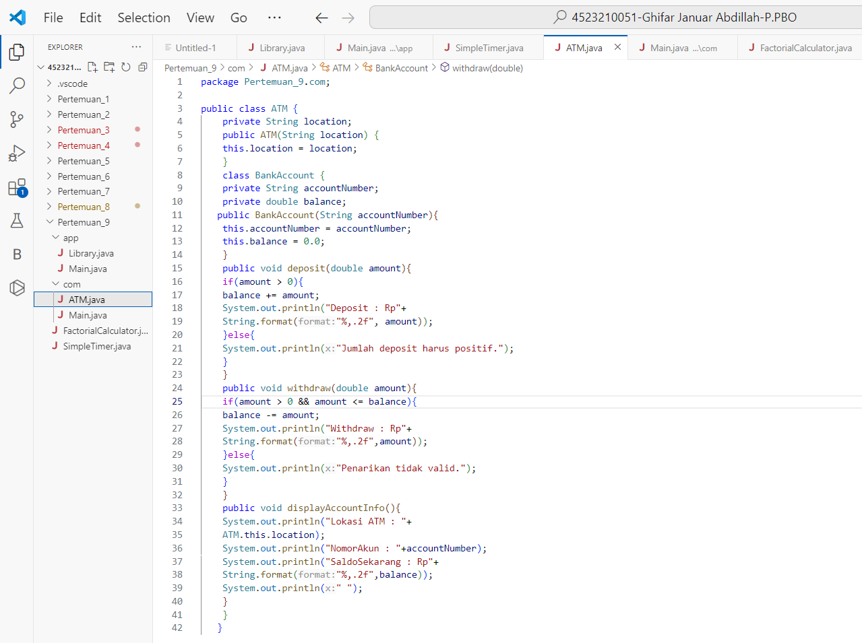

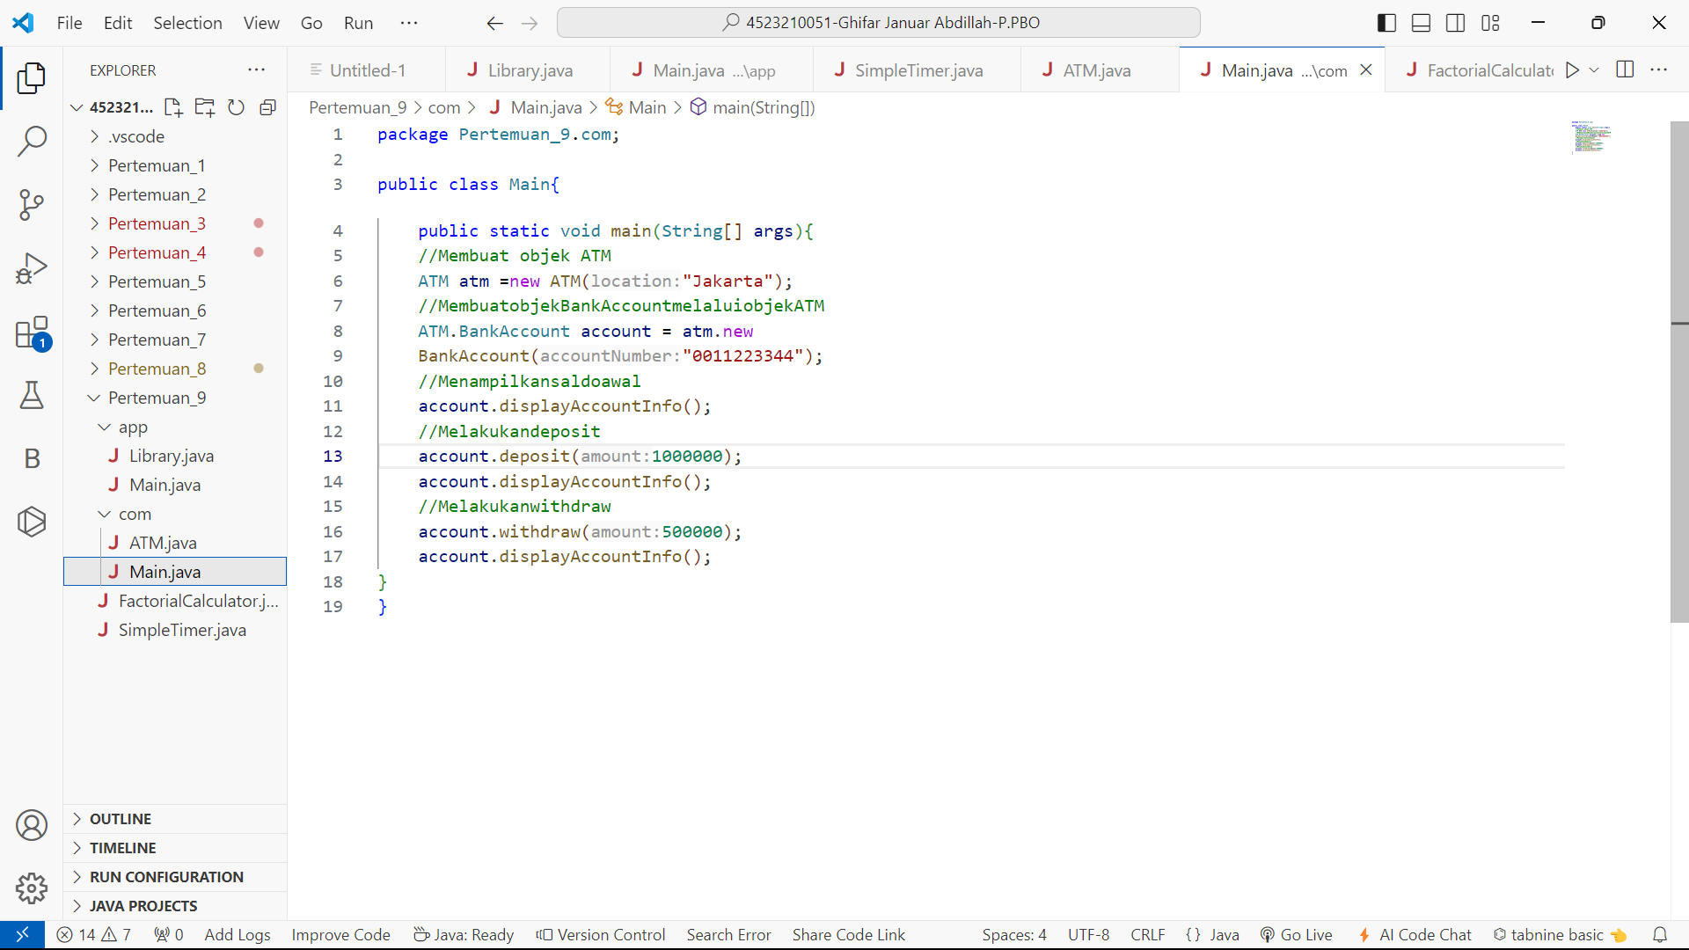

* Hasil Running

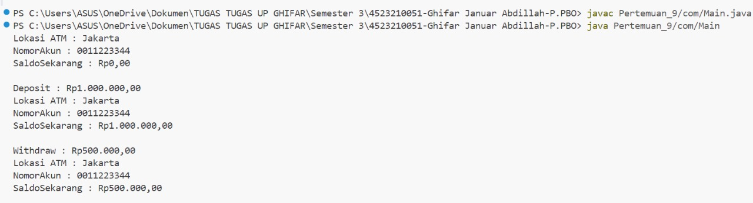

1. FactorialCalculator.java

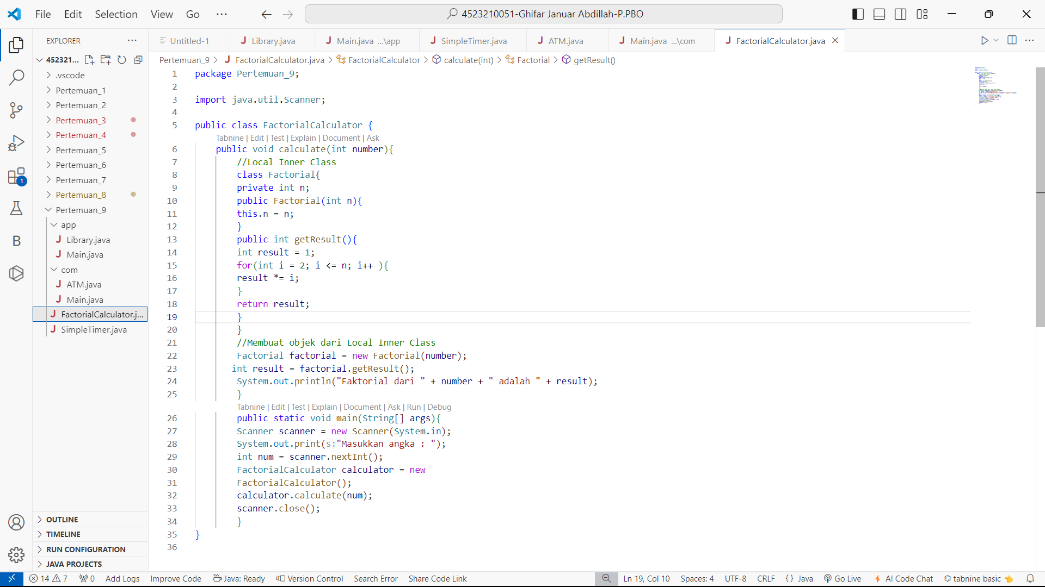

* Hasil Running



1. SimpleTimer.java

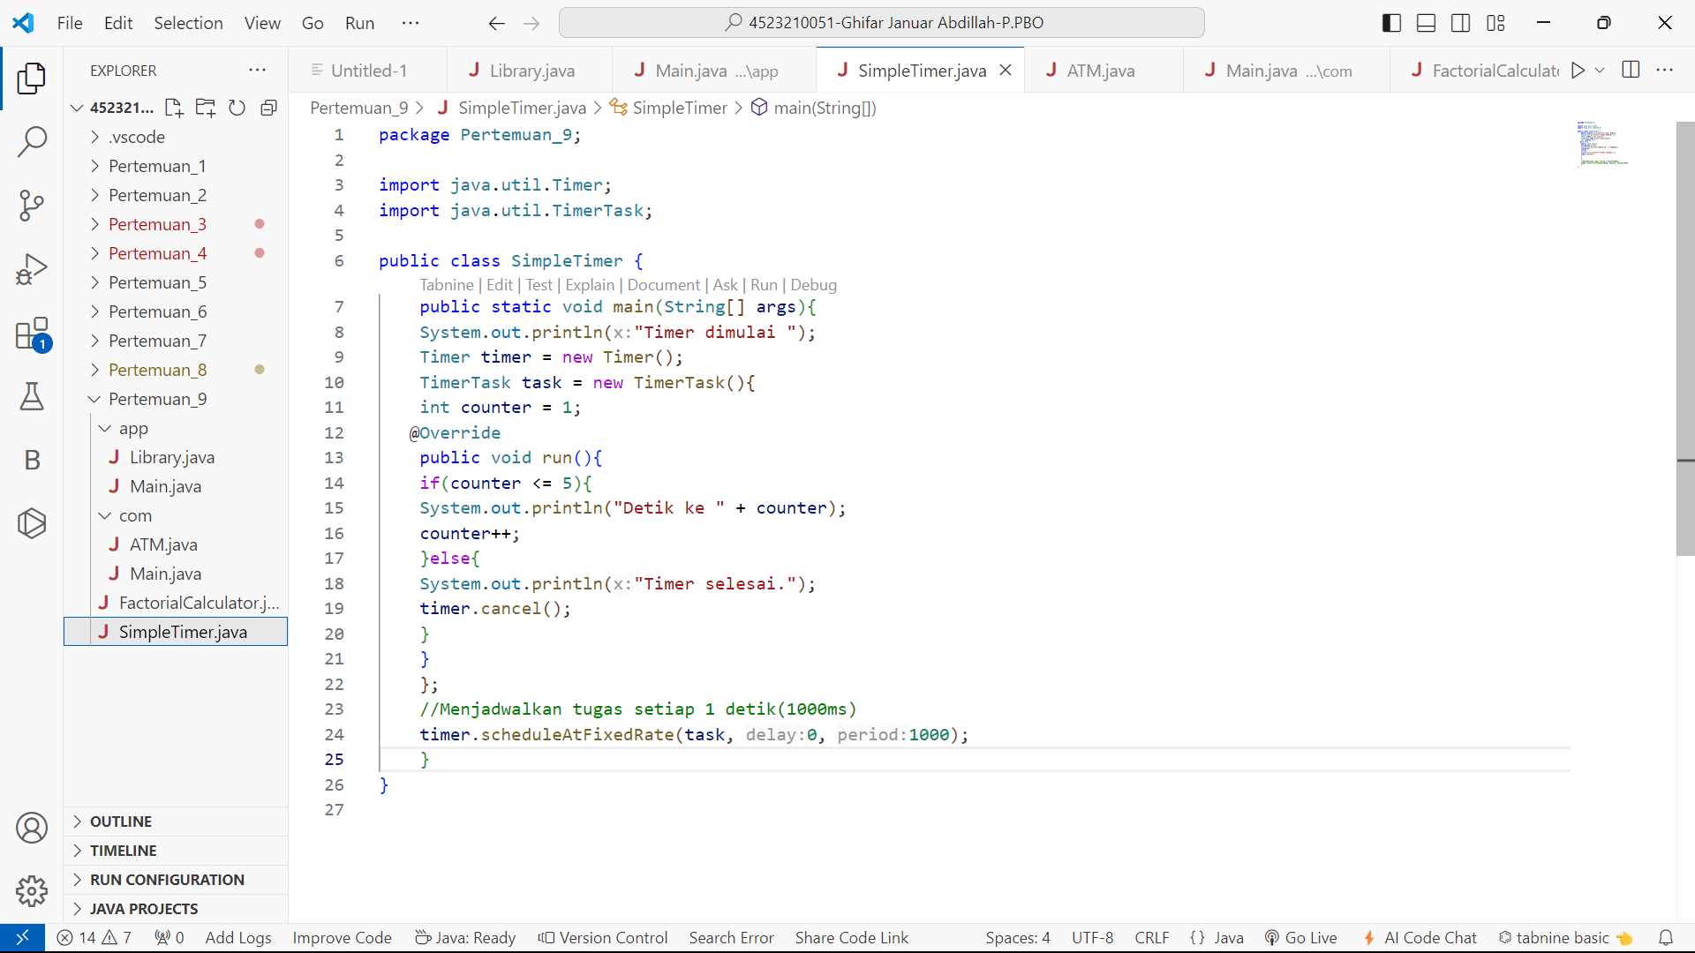

* Hasil Running

